

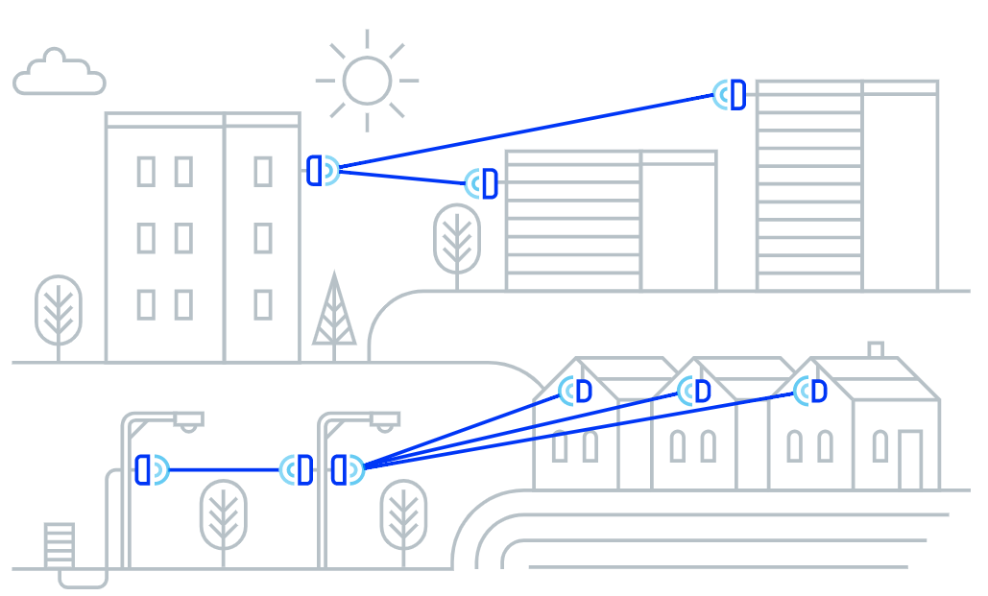

Architectural and Engineering Specification

AltoPlex D423

October 17, 2025

Summary
  - The intent of this document is to specify the minimum criteria for the design, supply, and installation of the AltoPlex D423 60GHz wireless radio.
  - Product: V band radio that provides wireless point-to-point and point-to-multipoint connectivity based on the 802.11ay standard, with 3-port 1GbE Ethernet support.
  - AltoPlex radios provide carrier-grade network connectivity for Ethernet applications such as high-definition megapixel cameras, multi-sensor cameras, and network video recorders (NVRs), as well as extending networks at fiber-quality speeds to provide Wi-Fi backhaul, smart city municipal building-top and street-level implementations, and connecting law enforcement locations.
  - Related requirements:
    - Features and functionality
      - Operation
      - Connectivity
      - Security
      - System management
    - Device Power
    - Device dimensions
    - Physical installation
    - Enclosure
    - Certifications

Specification
  - The AltoPlex D423 shall include the following features and functionality:
    - The D423 shall be able to function as a Distribution Node (DN) or Client Node (CN).
    - The D423 shall function in point-to-point (DN to DN) and point-to-multipoint (DN to CN) modes.
      - When functioning in DN mode, the D423 shall support 1 DN connection and 15 CN connections simultaneously.
    - The D423 shall provide 90° horizontal and +/-20° vertical coverage.
    - The D423 shall operate in the unlicensed 57-66GHz band.
      - The D423 shall provide 4 non-overlapping 2.16GHz channels within the 57-66GHz band.
      - Channel access shall be TDMA/TDD.
    - The D423 shall have 12 levels of Modulation and Coding Schemes from MCS-0 (BPSK) to MCS-12 (16QAM).
    - The D423 shall have a capacity of up to 2Gbps aggregate.
    - The D423 shall have less than 1ms latency.
    - Ethernet port:
      - The D423 shall have 3 RJ-45 1G BASE-T Ethernet port (with auto-negotiation to 100Mbps).
      - The D423's Ethernet ports shall provide 802.3bt Power over Ethernet (PoE):
        - 1 port active PoE input, 90W maximum.
        - 2 ports active PoE output, 60W maximum.
      - The D423 shall have IP67-rated ingress protection.
    - The D423 shall have transparent Ethernet bridging types including VLAN and VLAN stacking.
    - The D423 shall utilize hardware-based AES-128 encryption.
    - The D423 shall have an operating temperature range of -40° to +131°F (-40° to +55°C.)
  - System Management:
    - The D423 shall provide a WebUI accessed from a desktop browser for configuration, management, and monitoring.
      - The D423 shall also be optionally supported with AltoCommand, Altowav's enterprise management and monitoring UI.
      - The D423 shall be able to be operated without AltoCommand.
    - The D423 shall support various management protocols: HTTPS, SSH.
    - The D423 shall provide a REST API for management and monitoring.
    - The D423 shall provide the ability to save the unit configuration and upload it from local and remote connection.
      - Configuration backup and restore shall be supported via the REST API.
    - The D423 shall provide the ability to update configuration over the network (in-band).
    - The D423 shall provide the ability to upgrade software over the network (in-band).
    - The D423 shall default to using a static IP address.
      - The D423 shall be able to be configured to use dynamic IP address assignment (DHCP).
    - The D423 shall have a Wi-Fi management access point to allow for local wireless management of the device from a Wi-Fi-enabled PC, tablet, or hand-held device.
      - The Wi-Fi management access point shall provide management access to the device only; it shall not provide access to the internet or LAN.
      - The Wi-Fi management access point shall be able to be disabled.
      - The D423 shall use the device hostname as the access point name by default.
        - The name of the Wi-Fi management access point shall be configurable.
      - The IP address of the Wi-Fi management access point shall be configurable.
    - The D423 shall have a single green/red bi-color LED.
      - The LED shall provide visual indication of the status of the device, including:
        - When the device is waiting to form connections.
        - When the device has a wired connection and at least one wireless connection.
        - When the device is powering up.
        - When the device is in an error condition.
      - The D423 shall provide the ability to set the LED into "locate mode" which flashes a specific sequence to allow the device to be located.
      - The D423 shall provide the ability to disable the LED.
    - The D423 shall include an integrated Global Positioning System (GPS) receiver.
      - GPS shall provide location information for the D423.
      - GPS support shall be enabled by default.
      - GPS support shall be able to be disabled from within the WebUI.
  - Power:
    - The D423 shall support one Power over Ethernet (PoE) input port.
    - The D423 shall have two PoE output ports.
      - Total maximum PoE output of both ports shall be 60W.
      - Output of each PoE port shall be configurable:
        - Disabled
        - 30W
        - 60W
    - The D423 shall have a 12W maximum power consumption (not including PoE output).
  - Dimensions:
    - The D423 shall be 6.88 x 6.88 x 1.62 inches (174.75 x 174.75 x 41.15mm).
    - The D423 shall weigh 1.59lbs (720g)

  - Physical installation
    - The D423 shall provide wall-mounting and pole-mounting options without requiring additional brackets.
    - The D423 shall have an optional wall mount bracket.
      - The D423 shall be attached to the wall mount bracket by using band clamps.
      - The wall mount bracket shall enable azimuth adjustment.
      - The wall mount bracket shall have an optional pole extension to support multiple devices and increased elevation.
    - The D423 shall have an optional tilting mount bracket.
      - The tilting mounting bracket shall be able to be mounted to a wall or flat surface by using screws.
      - The tilting mounting bracket shall be able to be mounted to a pipe or pole by using band clamps.
      - The tilting mounting bracket shall allow for tilting elevation adjustments from +60° to -45°.
    - The D423 shall provide an IP67-rated cable gland for installation of an Ethernet cable.
  - Enclosure
    - Mechanical installation of the D423 shall not require special tools.
    - The D423 enclosure shall include all necessary link components:
      - Baseband.
      - Radio.
      - Scanning antenna.
      - GPS antenna and module.
    - The enclosure shall include the ability to be grounded.
    - The enclosure shall be made of cast aluminum A338.
    - The enclosure shall have a 60-100 microns power coating of pantone PMS 427C paint.
    - The D423 front cover shall be made of PC/ABS thermoplastic.
    - The front cover shall include 0.5% HALS 770 UV light stabilizer.
  - The D423 shall include the following certifications:
    - Radio:
      - FCC ID: Pending
      - IC: Pending
    - Wi-Fi management radio:
      - FCC ID: Pending
      - IC: Pending
    - ESD: IEC EN 61000-4-2
    - EMC: IEC EN 61000-4-3

