

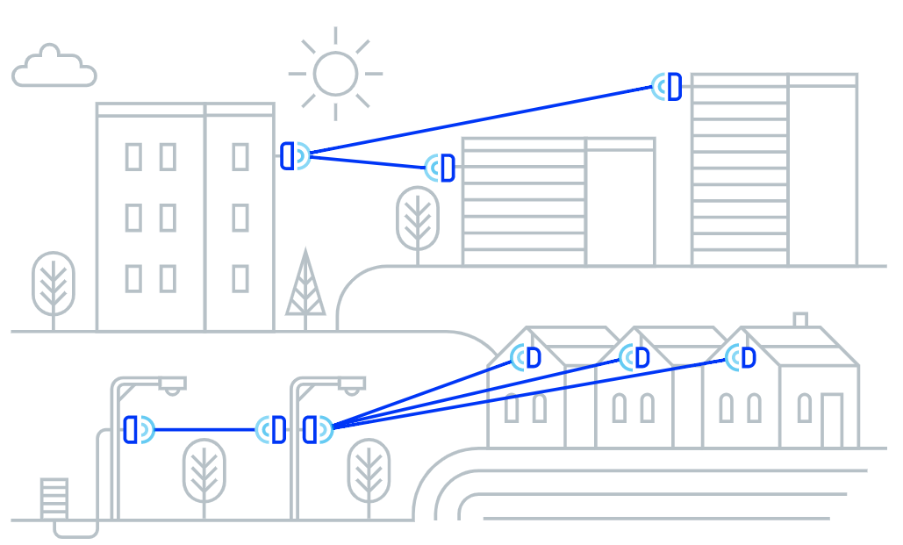

Architectural and Engineering Specification

AltoPlex D621

October 17, 2025

Summary
  - The intent of this document is to specify the minimum criteria for the design, supply, and installation of the AltoPlex D621 60GHz wireless radio.
  - Product: V band radio that provides wireless point-to-point and point-to-multipoint connectivity based on the 802.11ay standard, with 2.5GbE Ethernet support.
  - AltoPlex radios provide carrier-grade network connectivity for Ethernet applications such as high-definition megapixel cameras, multi-sensor cameras, and network video recorders (NVRs), as well as extending networks at fiber-quality speeds to provide Wi-Fi backhaul, smart city municipal building-top and street-level implementations, and connecting law enforcement locations.
  - Related requirements:
    - Features and functionality
      - Operation
      - Connectivity
      - Security
      - System management
    - Device Power
    - Device dimensions
    - Physical installation
    - Enclosure
    - Certifications

Specification
  - The AltoPlex D621 shall include the following features and functionality:
    - The D621 shall be able to function as a Distribution Node (DN) or Client Node (CN).
    - The D621 shall function in point-to-point (DN to DN) and point-to-multipoint (DN to CN) modes.
      - When functioning in DN mode, the D621 shall support 1 DN connection and 15 CN connections simultaneously.
    - The D621 shall provide 90° horizontal and +/-20° vertical coverage.
    - The D621 shall operate in the unlicensed 57-66GHz band.
      - The D621 shall provide 4 non-overlapping 2.16GHz channels within the 57-66GHz band.
      - Channel access shall be TDMA/TDD.
    - The D621 shall have 12 levels of Modulation and Coding Schemes from MCS-0 (BPSK) to MCS-12 (16QAM).
    - The D621 shall have a capacity of up to 3.8Gbps aggregate.
    - The D621 shall have less than 1ms latency.
    - Ethernet port:
      - The D621 shall have 1 RJ-45 2.5G BASE-T Ethernet port (with auto-negotiation speeds of 1Gbps/100Mbps).
      - The D621 shall have IP67-rated ingress protection.
      - The D621's Ethernet port shall be used to provide power to the device by using 802.3at Power over Ethernet (PoE).
    - The D621 shall have transparent Ethernet bridging types including VLAN and VLAN stacking.
    - The D621 shall utilize hardware-based AES-128 encryption.
    - The D621 shall have an operating temperature range of -40° to +131°F (-40° to +55°C.)
  - System Management:
    - The D621 shall provide a WebUI accessed from a desktop browser for configuration, management, and monitoring.
      - The D621 shall also be optionally supported with AltoCommand, Altowav's enterprise management and monitoring UI.
      - The D621 shall be able to be operated without AltoCommand.
    - The D621 shall support various management protocols: HTTPS, SSH.
    - The D621 shall provide a REST API for management and monitoring.
    - The D621 shall provide the ability to save the unit configuration and upload it from local and remote connection.
      - Configuration backup and restore shall be supported via the REST API.
    - The D621 shall provide the ability to update configuration over the network (in-band).
    - The D621 shall provide the ability to upgrade software over the network (in-band).
    - The D621 shall default to using a static IP address.
      - The D621 shall be able to be configured to use dynamic IP address assignment (DHCP).
    - The D621 shall have a Wi-Fi management access point to allow for local wireless management of the device from a Wi-Fi-enabled PC, tablet, or hand-held device.
      - The Wi-Fi management access point shall provide management access to the device only; it shall not provide access to the internet or LAN.
      - The Wi-Fi management access point shall be able to be disabled.
      - The D621 shall use the device hostname as the access point name by default.
        - The name of the Wi-Fi management access point shall be configurable.
      - The IP address of the Wi-Fi management access point shall be configurable.
    - The D621 shall have a single green/red bi-color LED.
      - The LED shall provide visual indication of the status of the device, including:
        - When the device is waiting to form connections.
        - When the device has a wired connection and at least one wireless connection.
        - When the device is powering up.
        - When the device is in an error condition.
      - The D621 shall provide the ability to set the LED into "locate mode" which flashes a specific sequence to allow the device to be located.
      - The D621 shall provide the ability to disable the LED.
    - The D621 shall include an integrated Global Positioning System (GPS) receiver.
      - GPS shall provide location information for the D621.
      - GPS support shall be enabled by default.
      - GPS support shall be able to be disabled from within the WebUI.
  - Power:
    - The D621 shall support Power over Ethernet (PoE) input.
    - The D621 shall have a 15W maximum power consumption.
  - Dimensions:
    - The D621 shall be 5.9 x 3.8 x 1.4 inches (150 x 95 x 35mm).
    - The D621 shall weigh 14 oz (400g)
  - Physical installation
    - The D621 shall provide wall-mounting and pole-mounting options without requiring additional brackets.
    - The D621 shall have an optional wall mount bracket.
      - The D621 shall be attached to the wall mount bracket by using band clamps.
      - The wall mount bracket shall enable azimuth adjustment.
      - The wall mount bracket shall have an optional pole extension to support multiple devices and increased elevation.

    - The D621 shall have an optional tilting mount bracket.
      - The tilting mounting bracket shall be able to be mounted to a wall or flat surface by using screws.
      - The tilting mounting bracket shall be able to be mounted to a pipe or pole by using band clamps.
      - The tilting mounting bracket shall allow for tilting elevation adjustments from +60° to -45°.
    - The D621 shall provide an IP67-rated cable gland for installation of an Ethernet cable.
  - Enclosure
    - Mechanical installation of the D621 shall not require special tools.
    - The D621 enclosure shall include all necessary link components:
      - Baseband.
      - Radio.
      - Scanning antenna.
      - GPS antenna and module.
    - The enclosure shall include the ability to be grounded.
    - The enclosure shall be made of cast aluminum A338.
    - The enclosure shall have a 60-100 microns power coating of pantone PMS 427C paint.
    - The D621 front cover shall be made of PC/ABS thermoplastic.
    - The front cover shall include 0.5% HALS 770 UV light stabilizer.
  - The D621 shall include the following certifications:
    - Radio:
      - FCC ID: 2AMP5-46211
      - IC: 22992-46211
    - Wi-Fi management radio:
      - FCC ID: 2AC7Z-ESPC3MINI1
      - IC: 21098-ESPC3MINI1
    - ESD: IEC EN 61000-4-2
    - EMC: IEC EN 61000-4-3

