

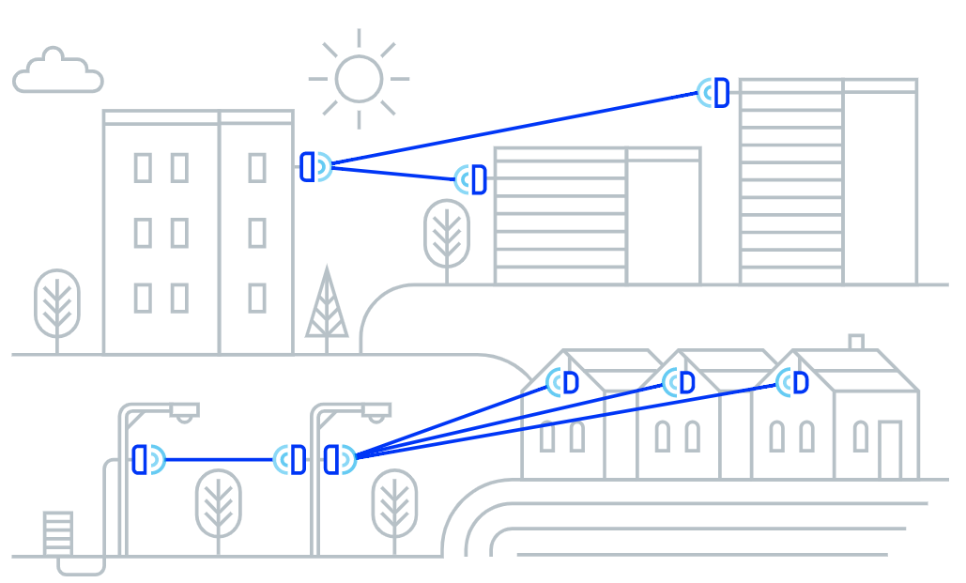

Architectural and Engineering Specification

Altowav K60

February 27, 2025

Summary
  - The intent of this document is to specify the minimum criteria for the design, supply, and installation of the Altowav K60 60GHz wireless radio.
  - Product: V band radio that provides wireless point-to-point and point-to-multipoint connectivity based on the 802.11ay standard, with 1GbE Ethernet support.
  - AltoPlex radios provide carrier-grade network connectivity for Ethernet applications such as high-definition megapixel cameras, multi-sensor cameras, and network video recorders (NVRs), as well as extending networks at fiber-quality speeds to provide Wi-Fi backhaul, smart city municipal building-top and street-level implementations, and connecting law enforcement locations.
  - Related requirements:
    - Features and functionality
      - Operation
      - Connectivity
      - Security
      - System management
    - Device Power
    - Device dimensions
    - Physical installation
    - Enclosure
    - Certifications

Specification
  - The Altowav K60 shall include the following features and functionality:
    - The K60 shall be able to function as a Hub or a Remote.
    - When operating in Hub mode, the K60 shall support up to 8 connections to Remotes.
    - The K60 shall provide 90° horizontal and +/-20° vertical coverage.
    - The K60 shall operate in the unlicensed 57-66GHz band.
      - The K60 shall provide 3 non-overlapping 2.16GHz channels within the 57-66GHz band.
      - Channel access shall be TDD.
    - The K60 shall have 8 levels of Modulation and Coding Schemes from MCS-0 (BPSK) to MCS-8 (QPSK).
    - The K60 shall have a capacity of up to 1.8Gbps aggregate.
    - The K60 shall have less than 1ms latency.
    - Ethernet ports:
      - The K60 shall have 2 RJ-45 1G BASE-T Ethernet ports (with auto-negotiation speeds of 1Gbps/100Mbps).
        - One K60 Ethernet port shall be used to provide power to the device by using 802.3af/at/bt Power over Ethernet (PoE).
        - One K60 Ethernet port shall be used as active 802.3af/at PoE output up to 30W.
      - The K60 Ethernet ports shall have IP67-rated ingress protection (requires HARTING IP67 connectors).
    - The K60 shall have transparent Ethernet bridging types including VLAN and VLAN stacking.
    - The K60 shall utilize hardware-based AES-128 encryption.
    - The K60 shall have an operating temperature range of -40° to +131°F (-40° to +55°C.)
  - System Management:
    - The K60 shall provide a WebUI accessed from a desktop browser for configuration, management, and monitoring.
      - The K60 shall also be optionally supported with AltoCommand, Altowav's enterprise management and monitoring UI.
      - The K60 shall be able to be operated without AltoCommand.
    - The K60 shall support various management protocols: HTTPS, SSH.
    - The K60 shall provide a REST API for management and monitoring.
    - The K60 shall provide the ability to save the unit configuration and upload it from local and remote connection.
      - Configuration backup and restore shall be supported via the REST API.
    - The K60 shall provide the ability to update configuration over the network (in-band).
    - The K60 shall provide the ability to upgrade software over the network (in-band).
    - The K60 shall default to using a preconfigured, unique static IP address.
    - The K60 shall be able to be configured to use dynamic IP address assignment (DHCP).
    - The K60 shall have a single green/red bi-color LED.
      - The LED shall provide visual indication of the status of the device, including:
        - When the device is in Hub mode and is the device operating normally.
        - When the device is in Remote mode and is waiting to form a link to a hub.
        - When the device is in Remote mode and is connected to a hub.
        - When the device is powering up.
        - When the device is in an error condition.
      - The K60 shall provide the ability to set the LED into "locate mode" which flashes a specific sequence to allow the device to be located.
      - The K60 shall provide the ability to disable the LED.
  - Power:
    - The K60 shall have Power over Ethernet (PoE) support:
      - One K60 Ethernet port shall be used to provide power to the device by using 802.3af/at/bt Power over Ethernet (PoE).
      - One K60 Ethernet port shall be used as active 802.3af/at PoE output up to 30W.
    - The K60 shall have a 8W maximum power consumption, not including PoE output.
      - Including PoE output, the K60 shall have a total power consumption of up to 38W.
  - Dimensions:
    - The K60 shall be 6.2 x 3.9 x 1.9 inches (157 x 99 x 48 mm).
    - The K60 shall weigh 14 oz (400g)
  - Physical installation
    - The K60 shall provide a pole/wall mounting bracket which allows for adjusting the vertical tilt.
    - The K60 shall have an optional wall standoff bracket that allows for azimuth adjustment when mounting the device to a wall.
    - The K60 shall provide an IP67-rated cable gland for installation of an Ethernet cable.
  - Enclosure
    - Mechanical installation of the K60 shall not require special tools.
    - The K60 enclosure shall include all necessary link components:
      - Baseband.
      - Radio.
      - Scanning antenna.
    - The enclosure shall include the ability to be grounded.

  - The K60 shall include the following certifications:
    - Radio:
      - FCC ID: 2AMP5K60
      - IC: 22992-K60
    - ESD: IEC EN 61000-4-2
    - EMC: IEC EN 61000-4-3

